1. Introduction

Thus, this work will investigate how the rate of reaction of magnesium with a solution of ethanoic (acetic) acid depends on concentration and temperature. Also, during the research, the Van't Hoff temperature coefficient and activation energy will be found.

2. Brief Summary from Theory

Chemical kinetics studies the change in the concentrations *С* of reactants and chemical's reaction products over time *t*. The reaction rate is determined for a distinct component as the change in concentration over time

$v= Δ C/ Δ t.$ (Eq.1)

Since the reaction rate is a positive quantity, the expression uses a sign plus if the rate is determined by the reaction product, and a sign minus if the rate is determined by the reactant.

The reaction rate depends on the nature of the reagents, their concentration, system's temperature, presence of a catalyst, contact area and other factors. The dependence of the reaction rate on concentration is expressed by the law of mass action (the basic law of chemical kinetics) which states that the reaction rate at a constant temperature is proportional to the product of the concentrations of the reacting substances in certain powers(1)

If two components *A* and *B* react, then this law can be written

$v=k{\left[A\right]}^{a}{\left[B\right]}^{b}$, (Eq.2)

where *a*, *b* are some numbers (reaction orders), [*A*] the concentration of substance *A*, [*B*] the concentration of substance *B*, *k* is the reaction rate constant.

For an elementary homogeneous reaction, which is carried out in one stage, the partial orders of the reaction are numerically equal to the stoichiometric coefficients in the reaction equation. For other types of reactions, reaction orders are determined empirically.

The effect of temperature on the rate of a chemical reaction is described by the empirical Van't Hoff equation(2)

, (Eq.3)

where *γ* is the temperature coefficient of the reaction rate, which is established experimentally. It has been found that in most cases *γ* is between 2 and 4.

Van't Hoff's equation is approximate. A more precise relationship between reaction rate and temperature was developed by S. Arrhenius. Using the Arrhenius theory, the Van't Hoff's equation can be justified(3). The most important conclusion from this theory is that any chemical reaction is accompanied by the molecules of the reacting substances that overcome the energy barrier $E_{a}$, which is called activation energy(4,5). The equation obtained by Arrhenius for the reaction rate constant has the form

$k=Aⅇ^{-\frac{E_{a}}{RT}}$, (Eq.4)

where *R* is 8.34 J ${mol}^{-1}K^{-1}$ molar gas constant, *T* is temperature, *A* is some constant.

3. Formulation of the Problem

For an investigation of the basic laws of chemical kinetics, it was decided to use the reaction of acetic acid with magnesium. The aim of the work was to study the basic kinetic laws. The reaction in general can be represented as the formula:

$2{CH}_{3}COOH(aq)+Mg(s)→{{(CH}_{3}COO)}_{2}Mg(s)+H_{2}(g)$. (Eq.5)

Acetic acid was used in the form of an aqueous solution (4.5 %). Since magnesium is in the solid phase, and the hydrogen which is released as a result of the reaction is a gas, the studied reaction is heterogeneous. This reaction of substitution hydrogen with magnesium occurs in two stages: in the first, acetic acid dissociated in water into ${2{CH}_{3}COO}^{-}$ and ${Mg}^{2+}$ ions, and in the second, magnesium is added and a hydrogen molecule is formed(6). As a consequence, this reaction of interaction of acetic acid with magnesium with the subsequent formation of magnesium acetate and the release of hydrogen is sequential and not elementary(7).

Also, the mechanism of interaction of reagents is much more complicated than in a homogeneous case, for example, in a reaction when the one of the components is gas. Indeed, for a chemical reaction to occur, it is necessary that the molecules of the reacting substances come into contact with each other. In our case, such interaction is limited by the fact that the magnesium atoms are immobile, since they are located in a piece of metallic magnesium. The reaction will occur when the ${CH}_{3}COOH$ molecules, moving in the solution, approach the $Mg$ surface. This occurs due to the diffusion of molecules in the solution. As is well known, the higher the concentration of ${CH}_{3}COOH$ in the solution, the higher the diffusion rate. After the reaction on the metal surface, the resulting hydrogen gas is removed from the metal surface and the salt ${{(CH}_{3}COO)}_{2}Mg$ is dissolved.

From the presented mechanism it is clear that the rate of this chemical reaction at a constant temperature will depend on the concentration of ${[CH}_{3}COOH$] and on the surface area of ​​magnesium. If we assume that the surface area of ​​magnesium does not change (it is under this condition that we will conduct in our experiment), then based on Eq.(2) following equation for the rate of the given chemical reaction can be assumed(8):

. (Eq.6)

The first **aim** of this work is to verify the validity of Eq.(6) for reaction Eq.(5) and find the parameters $k$ and $a$.

The second **aim** of the work is to study the effect of temperature on the rate of reaction Eq.(5), i.e. clarification of the validity of Eq.(3) and determination of the temperature coefficient of the reaction rate, as well as finding the activation energy in the Arrhenius formula Eq.(4).

Hypothesis

The reaction rate of acetic acid with magnesium depends on the acid concentration in a power-law manner(1,8) according to Eq.(6), while its dependence on temperature follows the Van't Hoff law(2,3) Eq.(3) and the Arrhenius equation(4,5) Eq.(4).

Research Question

Will the reaction rate of acetic acid with magnesium follow the Van't Hoff and Arrhenius laws and depend on the acid concentration in a power-law manner?

4. Experimental Technique. Methodology

Variables

Independent variable: In this investigation, there are two independent variables being individually manipulated. The first variable is concentration of ethanoic acid while temperature was kept constant. The second variable is temperature while concentration of ethanoic acid was constant.

Dependent variable: The dependent variable in this experiment is the rate of the reaction between ethanoic acid and magnesium.

Table 1. Part (A). Independent variable – concentration, temperature is constant

| **Variable** | **Importance to control** | **Method to control** |
| --- | --- | --- |
| Temperature | Since the aim is investigate the role of concentration at rate of the reaction, the temperature is kept constant to ensure it does not cause unwanted changes in the reaction rate by altering collision rate and frequency, consequently having an effect on the rate constant. | The desired temperature was 25 $±0.5℃$ will be maintained using a water bath (1 liter) with magnetic stirrer and glass thermometer. |
| Volume of acid | The volume of acid is kept constant, to minimize the impact of this parameter. | In each experiment total volume of solution (35 ml). The volumetric ratios of water and acid was controlled using a pipette. |
| Contact surface and mass of $Mg$ | The surface area of the $Mg$ contact is kept constant so as not to cause undesirable changes in the reaction rate by changing the surface area. (It is well known that when the surface area decreases, the reaction rate decreases). | The same mass of $Mg$ (0.15 g) was cut from the Magnesium metal ribbon coil, since density is constant and identical geometrics characteristics was used in the experiments, means that surface area of $Mg$ piece was constant. |

Table 2. Part (B). Independent variable – temperature, concentration is constant

| **Variable** | **Importance to control** | **Method to control** |
| --- | --- | --- |
| Concentration | Since the aim is investigate the role of temperature at rate of the reaction, the concentration is kept constant to ensure it does not cause unwanted changes. The rate of reaction depends on the concentration of reactants. The greater concentration of reacting substances, the more often the molecules collide and the faster the reaction takes place. | Concentration was kept constant using a pipette 0.632 mol ${dm}^{-3}$ (0.022 moles). |
| Volume of acid | (Same as in Table 1) | (Same as in Table 1) |
| Constant contact surface are of $Mg$ (with mass) | (Same as in Table 1) | (Same as in Table 1) |

To achieve the aim set in the work, an experimental setup was completed (see Fig. 1), the characteristics of the used equipment are given in Table 3.

|  |  |
| --- | --- |
|  |  |
| (a) | (b) |

Fig. 1. Photos of the experimental setup from different perspectives. (a) Experimental setup and Redmi Note 10 video camera used for experiment. (b) Detailed image of the syringe (150 ml) for collecting the released hydrogen

Table 3. Apparatus and materials used in experimental setup

| **Apparatus** | **Quantity** | **Uncertainty** | **Employment** |
| --- | --- | --- | --- |
| Glass syringe | 1 | $$±0.5 ml$$ | Used to collect hydrogen |
| Electronic balance | 1 | $$±0.01 g$$ | Used to measure equal weight of $Mg$ (0.15 g) |
| Timer | 1 | $$±0.1 s$$ | Used to measure the time period taken to collect $H_{2}$ in syringe |
| Glass thermometer | 3 | $$±0.5 K$$ | Used to measure and monitor the temperature of the water bath, acetic solution and temperature of room |
| Volumetric pipette 5 ml | 1 | $±$ 0.01 ml | Used to create solutions of different concentration |
| Holder | 3 | - | Used to hold test tube (and thermometer), syringe and video camera |
| Rubber tube | 1 | - | Used connect syringe with test tube and transfer $H_{2}$ |
| Test tube | 1 | - | Used to immerse in water bath, where the reaction took place |
| Cork(cup) | 1 | - | Used to close the test tube |
| Beaker 50 ml | 2 | Not important for the experiment | The flask where acetic-acid(from canister) and water were placed before creating solution |
| Magnetic stirrer | 1 | - | Used to stir water in the water bath for creation equal temperature through all of the volume |
| Graduated cylinder ml | 1 | $$±0.5 ml$$ | The cylinder where acetic acid and water were placed using pipette |
| Water Bath (1 ${dm}^{3}$) | 1 | Not important for the experiment | A thermostatically controlled water bath was used to both manipulate the desired temperature of the reactants when independent variable was temperature, and maintain the reactants at 25 $℃$ when independent variable was concentration, in which the test tube containing the reactants will be immersed. |
| Heating plate | 1 | - | Used to heat water bath for a constant temperature |
| Ice cubes | 15 | - | Were placed instead of water bath to cool the solution until 7 $℃$. |
| Video camera | 1 | $±$ 1 s | Used to monitor piston displacement in the syringe. |
| Magnesium | Magnesium Ribbon 25*g* ($Mg$) – Roll Coil | | |
| Acetic acid | *Grape Vinegar PLATANIS white* 4*L*,  Acidity: 4.5% which is equivalent to 0.732 | | |

5. Experimental Procedure

This procedure and it’s safety considerations are shown in the Tables 4 and 5.

Table 4. Experimental steps

| **Part A** | **Part B** |
| --- | --- |
| Both reactants (water and acid) were placed from big canister to the two separate (50 ml) beakers. | |
| Temperature was constant 25 $℃$ Total volume of ethanoic acid, final concentration  and number of moles in a solutions were: | The concentration was constant.  0.632 mol ${dm}^{-3}$ 0.022 moles  Temperature of ethanoic acid:  1 |
| For each experiment was used 0.15 g of $±0.01g$. | |
| Created solution was placed into the test tube. Test tube was immersed into the water bath with constant temperature and has been held out until the solution had the same temperature as water bath. At the same time test tube was connected with rubber tube to syringe. Temperature of water bath was monitored by thermometer. | |
| The $Mg$ was immersed into the tube and tube was closed with cork. | |
| The Hydrogen started form in the tube and at the same time piston in the syringe began move. The process of piston displacement was recorded (with magnification) at video camera. | |
| As a result of each experiment, from 10 to 35 experimental values ​​were obtained. | |
| When experiment was completed, the temperature inside the test tube was measured, it’s found the temperature of the solution remained the same as in water bath. | |

Table 5. Safety considerations(9)

| **Chemicals**  **factors** | **Safety concerns** | **Safety protocol** | **Ethical and Environmental concerns** |
| --- | --- | --- | --- |
| Acetic acid | Highly flammable liquid. This acid can cause corrosion and burns if in contact with eyes or skin can cause nasal and respiratory irritation can cause major organ damage if ingested. | Acetic acid was kept away from burners, gas pipes, lighters, and any sort of instrument that could ignite a spark. A lab coat, mask, laboratory glasses, and gloves were worn at all  the times when handling acetic acid. | **Acetic** acid can cause adverse environmental effects if leaked into ecosystem. Thus it was neutralized with ${Na}_{2}{CO}_{3}$ to form harmless salts, that were then thoroughly diluted with excess water, before disposing off. No ethical concerns. |
| Hydrogen | Highly flammable gas thus can be ignited easily. Inhalation can cause nasal and respiratory irritation. | Hydrogen was kept away from burners, lighters and any sort of instrument that could ignite a spark. The room was well ventilated. | High concentrations of hydrogen in the air cause oxygen deficiency. This can lead to the risk of loss of consciousness. Therefore, the gas was released in small quantities (no more than 60 ml) in a well-ventilated room. No ethical concerns. |
| Magnesium acetate | This compound is a relatively safe compound to handle and has been given a health hazard rating of zero, however. Cause irritation, if it gets in the eyes or skin. | A lab coat, safety goggles, and gloves were worn at all the times when handling magnesium acetate. | No ethical or environmental  concerns. |
| Hot water in water bath | Use of high temperatures solution or water bath can cause significant burns in contact with skin. | The Highest temperature was $60℃$. So, it couldn’t have caused burns, despite that lab coat and gloves were worn. |

6. Data and Errors Analysis

A table of measurements of hydrogen volume versus time for various concentrations according to Table 4 (Part A) is given in Appendix 1. Tables of measurements of hydrogen volume versus time for different temperatures according to Table 4 (Part B) are given in Appendix 2.

Following example shows calculation of the reaction rate and uncertainty for one of used concentration of acetic acid ${ 0.43 mol dm}^{-3}$ based on the data obtained on the volume of hydrogen. For other values, rate of reaction and error bars are processed similarly. To calculate the uncertainty, information on absolute errors from Table 3 will be used.

Step 1

To create a solution with a concentration of ${0.429 mol dm}^{-3}$ from the starting materials (Table 3), $4$ pipettes of $5 ml$ of acid and $3$ pipettes of $5 ml$ of water were taken.

As a result: the desired concentration was obtained $\frac{0. 750{mol dm}^{-3} × 4 × 5ml}{3×5 ml + 4×5 ml}≈0.429 {mol dm}^{-3}$.

Relative uncertainty of concentration is $\frac{0.04}{20}+\frac{0.07}{35}=0.004$, and absolute uncertainty is $0.004 ×0.429 ≈ 0.002 {mol dm}^{-3}$.

The amount of mole of acid is calculated as ${n{(CH}_{3}COOH)}_{initial}=C×V_{solution }$, $0.429 {mol dm}^{-3} ×0.035 { dm}^{3} =0.015 mol$, hence the relative and absolute uncertainty are equal, respectively: $0.004+\frac{0.07}{35}=0.006$ и $0.006 ×0.015 mol= 0.0001$ $mol$.

Step 2

The dependence of the volume of hydrogen in the syringe on time was experimentally obtained. The number of moles of hydrogen over time was calculated from the assumption that the gas in the syringe is ideal10

, (Eq.7)

where $n\left(H_{2}\right)$ is number of moles of $H_{2}$, *T* is room temperature *297K* , *V $(H_{2})$* is volume of $H_{2}$ (which was collected in a moment of time), *p* is atmospheric pressure (which is *99992 Pa*).

At time *136 sec* volume of hydrogen in syringe was $V\left(H_{2}\right)=17 ml$, from Eq.(7) $n\left(H_{2}\right)=\frac{99992 Pa ×17{×10}^{-6}m^{3}}{8.34 J {mol}^{-1}K^{-1}×297K}= 0.00069 mol$. According to Table 3, the uncertainty in measuring the volume in a syringe is 0.5 ml. The relative uncertainty of the amount of hydrogen was calculated as $\frac{0.5}{17}=0.03$, which means that absolute is $0.00069× 0.03$ = 0.0000207 mol.

Step 3

Let's find the uncertainty of instantaneous/current concentration.

From Eq. (5)

$${n{(CH}_{3}COOH)}_{current} = 2 n\left(H_{2}\right).$$

Therefore, instantaneous/current concentration(10) of the reaction will be

${[CH}_{3}COOH]$ = $\frac{{n{(CH}_{3}COOH)}_{initial}- {n{(CH}_{3}COOH)}_{current}}{V_{solution }}$ mol ${dm}^{-3}$;

${[CH}_{3}COOH]$ = $\frac{0.015- 2×0.00069}{0.035}$ = 0.389 mol ${dm}^{-3}$.

Relative uncertainty

+ 0.0118 = 0.012.

Thus, absolute uncertainty is ${0.389 mol dm}^{-3}$ $× 0.012 = 0.005 mol {dm}^{-3}$.

By repeating steps 1-3, values of concentrations ​​at other points in time can be obtained.

The results are shown in Table 6 (the example considered above is highlighted in gray).

Table 6. Dependence of acid concentration on time

As follows from the data obtained (see Fig. 2), the dependence of the acid concentration on time of reaction is linear. According to Eq.(1), let's find the reaction rate as the gradient of the plotted line. From the graph, we see that gradient is $0.00024$.

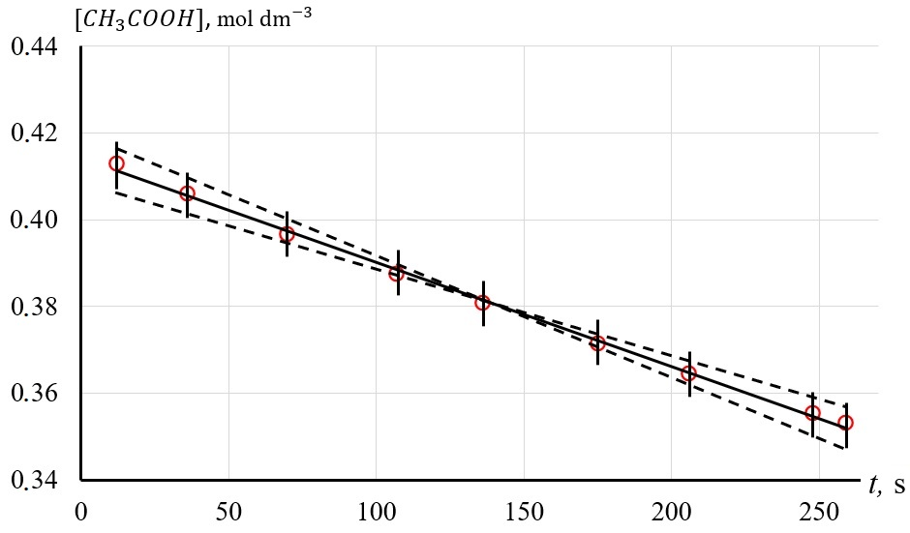

Fig. 2. Dependence of acid concentration on reaction time. (Solid line corresponds to trend line. Dashed lines are used for demonstration of confidence interval)

To calculate the uncertainty, the steepest and least steep lines through the error bars as shown will be drawn. This gives Max gradient 0.00028 and Min gradient 0.00020, therefore uncertainty in the gradient is $\frac{0.00028- 0.00020}{2}$ $=$ 0.00004, which is 16.7% of the average value. Thus, for concentration of acetic acid 0.429 ${ mol dm}^{-3}$ $±0.002 {mol dm}^{-3}$, the rate of reaction will be 0.00024 .

7. Results

7.1 Determination of the Reaction Rate Constant

According to section 6, reaction rates and uncertainties were obtained for each of the concentrations following the experimental steps which are presented in part A given in Table 4. These results are shown in Fig. 3. According to the presented results and Eq.(6), it can be assumed that *a* = 1. The coefficient *k* can be calculated as 5,9 $×{10}^{-4}$ $s^{-1}$.

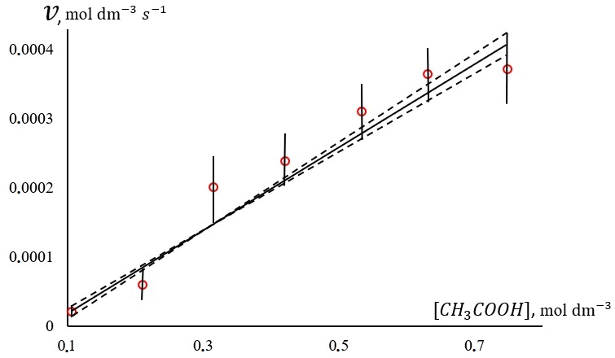

Fig. 3. Dependence of the reaction rate constant on the concentration of acetic acid. (Solid line corresponds to trend line. Dashed lines are used for confidence interval)

To calculate the error, the steepest and least steep lines through the error bars as shown will be drawn. This gives Max gradient 6.18 $×{10}^{-4}$ and Min gradient 5.5 $×{10}^{-4}$, then the uncertainty in the gradient $\frac{6.18×{10}^{-4} - 5.5 ×{10}^{-4}}{2}$ $= 3.4 ×{10}^{-5}$, which is 5% of the mean.

7.2 Determination of the Van't Hoff Factor

According to following the algorithm discussed in section 6, reaction rates and their uncertainties were obtained for the temperatures given in Table 4 (Part B). These results are shown in Fig. 4.

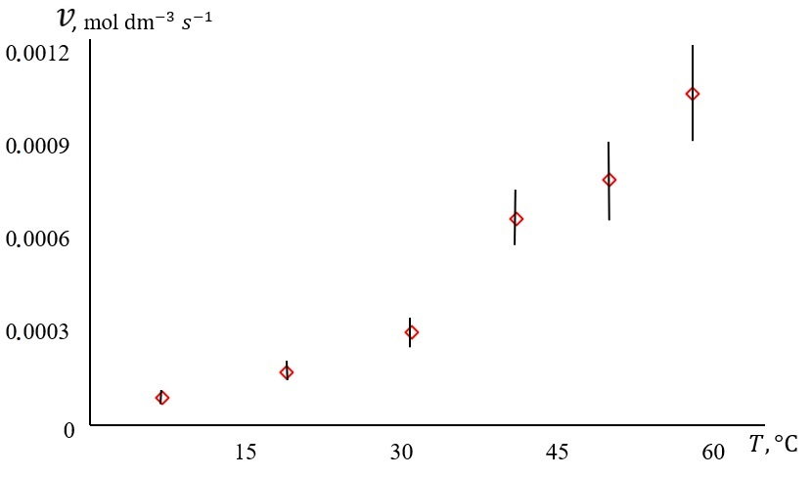

Fig. 4. Dependence of reaction rate on temperature. (Solid line corresponds to trend line. Dashed lines are used for confidence interval)

To determine the Van't Hoff factor, logarithm of Eq.(3) was taken. Therefore,

$\ln{\frac{v_{2}}{v_{1}}}=\left(\frac{T_{2}-T_{1}}{10}\right)\ln{γ}$. (Eq.8)

According to Fig. 4, initial values $v_{1}$ ​ and $T_{1}$ which are equal to 0.0000889 ${mol dm}^{-3} { s}^{-1}$ and 7 $℃$ respectively were chosen. Let’s plot dependence at Fig. 4 in the axes $\ln{\frac{v_{2}}{v_{1}}}\left(\frac{T_{2}-T_{1}}{10}\right)$. This graph is shown on Fig. 5. According to the presented results and Eq.(8), the slope of the linear function corresponds to $\ln{γ}$ which is equal to 0.48. To calculate the uncertainty, the steepest and least steep lines through the error bars as shown will be drawn. This gives Max gradient 0.75 and Min gradient 0.25, thus uncertainty in the gradient is $\frac{0.75 - 0.25}{2}$ $= 0.25$, so $\ln{γ}=0.48 ±0.25$ this means that the Van't Hoff factor is $γ=1.62$ $±0.41$ which is 25% of the mean

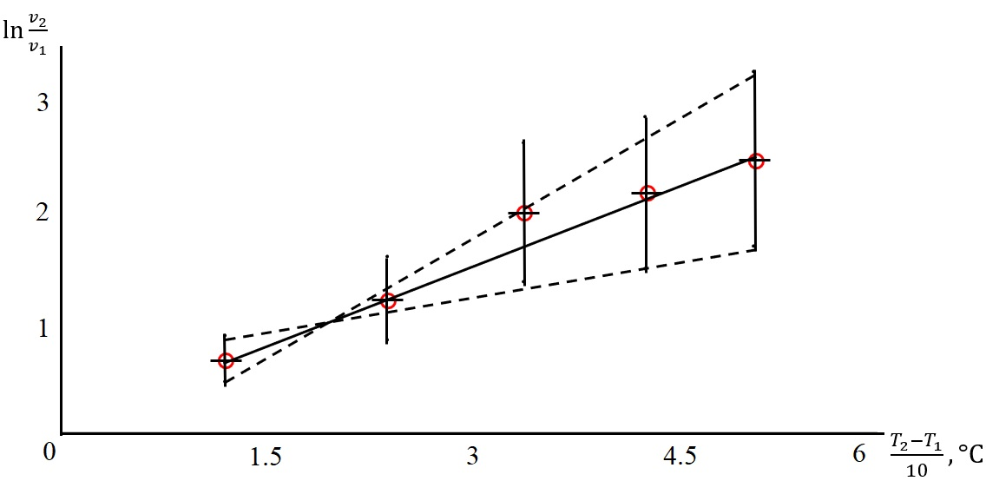

Fig. 5. Dependence of the logarithm of the reaction rates ratio on the temperature difference. (Solid line corresponds to trend line. Dashed lines are used for confidence interval)

7.3 Determination of the Activation Energy

Let's find the activation energy which is included in the Arrhenius equation. Thus, logarithm of Eq.(4) was taken

$\ln{k}=\ln{A}- \frac{E_{a}}{R T}$. (Eq.9)

Using the algorithm for finding the dependence *v(c)* from section 6, reaction rate constants for each of the temperatures given in Table 4 (Part B) can be determined. Having the dependence *k(T),* these data according to Eq.(9) can be transformed. These data are presented in Fig. 6. According to the presented results, ln *k* of *1*/*T* is a linear function with a slope of -4655. Activation energy according to Eq.(9) is equal to $E_{a}=4655 R= 38.8 kJ/mol$.

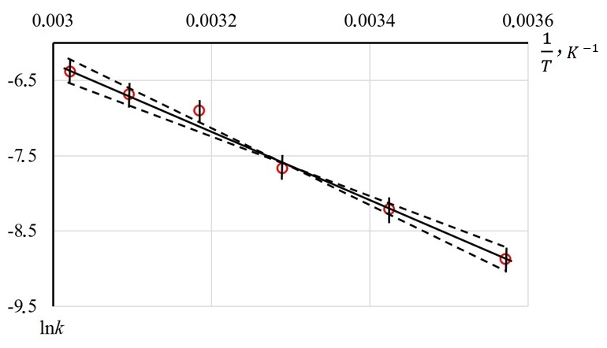

Fig. 6. Dependence of the logarithm of the reaction rate constant on the inverse absolute temperature. (Solid line corresponds to trend line. Dashed lines are used for confidence interval)

To calculate the uncertainty of the activation energy, the steepest and least steep lines through the error bars as shown in dotted lines were drawn. This gives Max gradient -5500 and Min gradient -4166, this is equivalent to $E_{a}=5500 R=45.9 kJ { mol}^{-1}$ and $E_{a}=4166 R=$ $34.7 kJ{ mol}^{-1}$, respectively, therefore uncertainty in activation energy is $\frac{45.9 - 34.7}{2}$ $= 5.6 kJ{ mol}^{-1}$, which is 14% of the mean value. Thus .

8. Conclusion

The kinetics of the chemical heterogeneous reaction of acetic acid (aq) with magnesium (s) was studied and the following results were obtained.

**Effect of concentration**: It has been found that increase of acetic acid in concentration leads to increase in reaction rate. This is consistent with theoretical conception about the dependence of the reaction rate on the concentration of reagents. The reaction rate constant was found and equal to $5,95±0.34$ $×{10}^{-4} s^{-1}$ (see Fig. 3).

**Effect of temperature:** Increasing the temperature accelerates the reaction.

**Van't Hoff factor**: The Van't Hoff factor has been established to be $1.62±0.41$ (see Fig. 5).

**Activation energy**: The calculated activation energy for the reaction is $38.8±5.6 kJ {mol}^{-1}$ (see Fig. 6).

Thus, the experiments carried out confirmed the existing literature data on the dependence of the rate of a chemical reaction on concentration and temperature. The obtained values ​​of the chemical reaction constants, Van't Hoff factor and activation energy are consistent with previously obtained ones in the Ref(3).

9. Evaluation

**Strengths:**

1. Theoretical reliability is based on the application and confirmation of known laws of chemical kinetics, such as the Arrhenius equation and Van't Hoff's law.
2. Careful planning and realization of the experiment. Particularly:
   * control of external variables such as temperature and pressure during the experiment minimized possible uncertainties;
   * the use of a water bath ensured that a constant temperature was maintained throughout the entire volume of the acid during the reaction, which helped to minimize the influence of this parameter on the reaction rate;
   * the use of common techniques, such as collecting the released gas in a syringe and using a video camera to detect the movement of the piston, led to more precise data.
3. Calculation and control of uncertainty. As can be seen from the presented results, their uncertainty is within 25%. The obtained values within uncertainty are coincide with found earlier(11).
4. Using graphical analysis. Plotting the dependence of the reaction rate on concentration and temperature allowed visually evaluate the data and identify trends.
5. Validation of results. Comparison of the results obtained with literature data and theory confirms their correctness and reliability.

Table 7. Limitations and Error evaluation

| **Source of error** | **Significance and type of error** | **Improvement** |
| --- | --- | --- |
| When preparing magnesium samples, their surface was treated to remove magnesium oxide using an abrasive material. | Surface treatment could lead to different areas of contact between Mg and acid in the experiments. This could affect the rate of reaction, which could lead to a random error. | Use magnesium with a clean, pre-chemically treated surface. |
| Usage of the model of ideal gas  for hydrogen in a syringe. | Could distort the real  number of moles of gas in the syringe and led to systematic error. | Use a semi-empirical equation of state for hydrogen gas. |
| Possible loss of hydrogen due to rubber tube connection. | Could distort amount of hydrogen which was collected in the syringe and led to systematic error. | Use a stronger seal and glass tube. |
| Few number of repetitions of the experiment. | Could lead to an uncertainty and reduces the accuracy of the results by increasing the random error. | Make a repeat measurement design to reduce the uncertainty. |
| Heterogeneity of the reaction  solution. | During the reaction, its products could be unevenly distributed in volume of solution which could affect the reaction rate and led to the random error. | It is necessary to use additional stirring, special magnetic stirrers can be used. |

10. Further Scope and Application of Investigation

In the future, it is planned, firstly, to eliminate the weaknesses noted in the Table 7 especially preparation of magnesium samples. Secondly, expand the range of concentrations and temperatures studied to verify that the patterns found in the work are valid and that there are no anomalies in their behavior. Thirdly, for a given reaction, investigate the effect of pure surface area of magnesium on the reaction rate. Fourthly, establish the thermodynamic characteristics of the reaction such as the change in enthalpy, entropy and Gibbs free energy to show the correlation between these thermodynamic characteristics and kinetics of the reaction.

The experimental setup and methodology used in this work can be used to study the rates of chemical reactions that are important for practical use in pharmaceutical, cosmetic, food and agricultural technologies. This can allow technological, economical and environmental benefits to be achieved. The studied kinetics of the formation of magnesium acetate is important because this chemical product is used as an antiseptic and disinfectant, a fixative in calico printing and a catalyst in organic synthesis.

and various temperatures